SPECIFIC AIMS
Listening to someone’s voice in a crowded room is a difficult task in many circumstances, but especially so for the hearing impaired. Behavioral and electrophysiological studies aimed at understanding how we distinguish sounds in an auditory scene have documented that segregation of distinct sound sources, stream segregation, takes time to build up. We use a well-documented ABA_ stimulus for which probability of segregation can be easily manipulated via stimulus parameters DF, the difference in frequency between A and B pure tones, and PR, presentation rate. For intermediate parameters, subjects initially hear the tones grouped in an integrated percept, and only after some time do they split into segregated streams. Importantly, these ambiguous stimuli elicit perceptual bistability, a feature we exploit to produce a novel account of buildup.
Our goal is to attack the stream segregation problem with new computational methods for data analysis and modeling. Our working hypothesis is that the neural populations which subserve stream segregation can demonstrate bistability between two different representations of an auditory scene, corresponding to integration or segregation, even though the input is not changing. We have used this feature to develop a novel statistical model to describe the dynamics of buildup. With this model, we relate the time course of a listener to achieve segregation for an ambiguous stimulus to the dominance durations for each percept. Using the tools of dynamical systems analysis, we propose neuronal-like processes that are sufficient to reproduce these properties.
The work proposed in Aims 1-3 is expected to produce novel descriptions and explanations for the dynamics of stream segregation. The positive impact of these results are many and varied; first and foremost, we reject the assumption that buildup necessarily reflects a gradual accumulative process. We demonstrate that the apparent steady increase in probability of segregation over time is really just an artifact of averaging over events which occur suddenly, but randomly. In addition to providing an alternative explanation for buildup, this research will enable new methods for identifying and measuring both stimulus-driven and central processes driving segregation, like strength of streaming cues, timescales of adaptation, context, and memory.
Aim 1: An alternating renewal process (ARP) can account for the time course of buildup, the increased probability of stream segregation over time. The model suffices without invoking any mechanism for evidence accumulation.
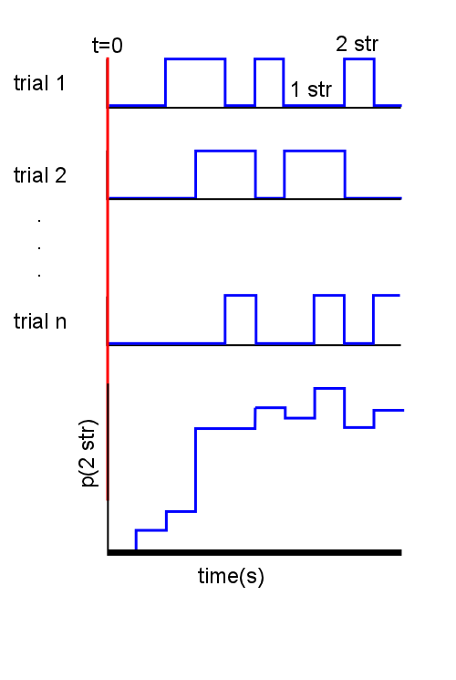Schematic of a buildup function. The smooth increase in segregation over time is actually a consequence of averaging random switches from a fixed starting state
We believe that the buildup psychometric function, rather than reflecting accumulation, is just the consequence of averaging over trials of the random and independent switching between two perceptual organizations. Using the model of an alternating renewal process, we demonstrate that the independent distributions of percept durations are the determining factors for describing the buildup psychometric function. The model is consistent with preliminary results from our experiments with both long and short trials with an ambiguous auditory stimulus.
Aim 2: Neural competition networks are sufficient to reproduce psychophysical results as well as the behavior of the ARP model.
Preliminary results from an idealized neuronal-like competition model show good correspondence with the empirical behavioral data. Additionally, we were able to achieve excellent accounting of the competition model’s dynamic buildup and alternations with our switching model. We will enhance the model to account for effects of context (Aim 3).
Aim 3: The effects of previous exposure and context will lead to significant changes in both buildup and alternation statistics. The models will be applied and enhanced in order to account for context effects.
With new experiments which manipulate previous context, we can measure stream segregation probability, buildup, and alternations in a dynamically changing auditory scene. We expect to see a strong effect towards maintaining the current perceptual state during changes in the stimulus, for which, using the computational models we have developed, we can make detailed measurements and propose potential mechanisms.

